**Pune Institute of Computer**

**Technology**



**Department of Computer Engineering**

(2022- 2023)

**“Develop a Blockchain based application for health-related**

**medical records”**

**Submitted to the**

**Savitribai Phule Pune University**

**In partial fulfillment for the award of the Degree of**

**Bachelor of Engineering**

**in**

**Computer Engineering**

**By**

|  |  |  |
| --- | --- | --- |
| **1)** | **Anuj Mutha** | **41443** |
| **2)** | **Nidhi Patil** | **41447** |
| **3)** | **Amit Purohit** | **41450** |

**Problem Statement**

Develop a Blockchain based application for health-related medical records.

**Objective**

To develop a Blockchain based application for health-related medical records.

**Theory**

A blockchain is a distributed system that generates and stores data records. It maintains a digital ledger of connected “blocks” of information that represent how data is shared, changed or accessed on its peer-to-peer network.

Blockchain is an emerging technology useful to provide innovative solutions in various sectors, including healthcare.

A Blockchain network is used in the healthcare system to preserve and exchange patient data through hospitals, diagnostic laboratories, pharmacy firms, and physicians. Blockchain applications can accurately identify severe mistakes and even dangerous ones in the medical field. Thus, it can improve the performance, security, and transparency of sharing medical data in the health care system. This technology is helpful to medical institutions to gain insight and enhance the analysis of medical records.

The medical industry has suffered greatly from the inability to securely share and access sensitive patient data. Blockchain, however, will facilitate finely customizable openness while upholding only the best security standards for true interoperability. In turn, this will allow health information systems to work together within and across organizational boundaries in order to advance the effective delivery of healthcare for individuals and communities.

**CODE :**

pragma solidity 0.8.7;

* SPDX-License-Identifier: MIT
* BT Mini - Project - Build a medical records application
* Group members: 41108 Medha Badamikar, 41117 Udayan Chavan, 41122 Tejas Deshpande

contract PatientInfo {

struct Patient {

string id;

string name;

string phone;

string treatment;

}

Patient[20] PatientInfoArray;

uint i=0;

// Function to register a patient

function registerPatient(string memory _pat_id, string memory _name, string memory _phone, string memory _treatment) public returns(string memory) {

Patient memory patient = Patient(_pat_id, _name, _phone, _treatment); if(i > 20) {

return "Limit reached";

}

else {

PatientInfoArray[i] = patient;

i += 1;

return "Patient registered...";

}

}

// Function to display patient data

function getPatient(uint idx) public view returns(string memory){ Patient memory patient = PatientInfoArray[idx];

return string(bytes.concat("Patient id: ", bytes(patient.id), ", Name: ", bytes(patient.name), ", Phone: ", bytes(patient.phone), "Treatment: ", bytes(patient.treatment)));

}

}

**OUTPUT :**

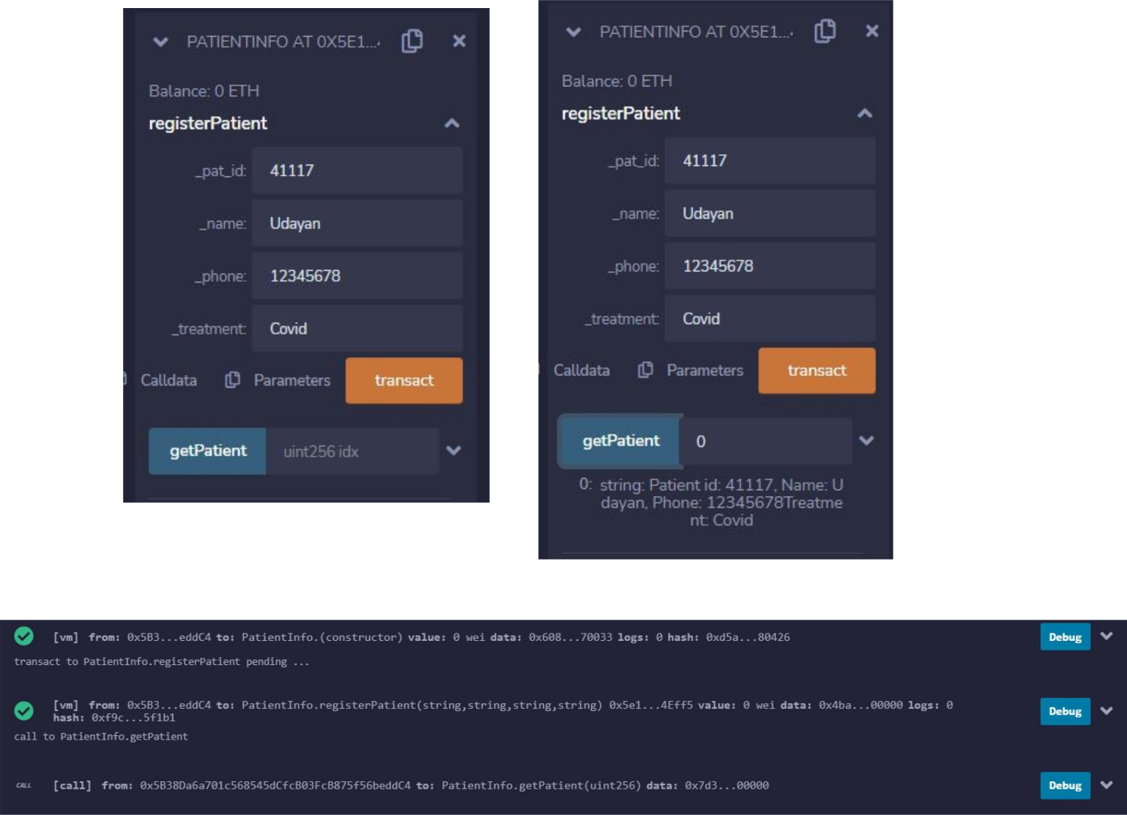

**Conclusion**

We have developed a Blockchain based application for health-related records and deployed it on Ethereum.